Example: Splitter Control, Enabling and Identifying Multiple Row Selection, Events: TOOLBAR, USER_COMMAND, MENU_BUTTON
REPORT Z930ALV5.
data : v_vbeln type vbak-vbeln.
select-OPTIONS so_vbeln for v_vbeln DEFAULT '4980' to '4985'.
data : cust_cont type ref to cl_gui_custom_container,
o_split type ref to cl_gui_splitter_container,
o_cont1 type ref to cl_gui_container,
o_cont2 type ref to cl_gui_container,
vbak_grid type ref to cl_gui_alv_grid,
vbap_grid type ref to cl_gui_alv_grid.
data : t_fcat type lvc_t_fcat,
wa_fcat type lvc_s_fcat.
types : begin of ty_vbak.
include type zcvbak.
types end of ty_vbak.
data : t_vbak type table of ty_vbak,
temp_vbak type table of ty_vbak,
wa_vbak type ty_vbak.
types : begin of ty_vbap.
include type zcvbap.
types end of ty_vbap.
data : t_vbap type table of ty_vbap,
wa_vbap type ty_vbap.
data wa_button type stb_button.
data wa_layo type lvc_s_layo.
data : t_rows type lvc_t_row,
wa_row type lvc_s_row.
class lcl_eventreceiver DEFINITION.
public SECTION.
methods handle_toolbar
for event toolbar
of cl_gui_alv_grid
importing e_object.
methods handle_user_command
for event user_command
of cl_gui_alv_grid
IMPORTING e_ucomm.
methods handle_menu_button
for event menu_button
of cl_gui_alv_grid
importing e_object e_ucomm.
endclass.
class lcl_eventreceiver IMPLEMENTATION.
method handle_toolbar.
* message 'toolbar event' type 'I'.
* logic for enabling / disabling std.alv toolbar button
clear wa_button.
read table e_object->mt_toolbar into wa_button
with key function = cl_gui_alv_grid=>mc_fc_find
TRANSPORTING function disabled.
if sy-subrc eq 0.
wa_button-disabled = 'X'.
modify table e_object->mt_toolbar from wa_button
TRANSPORTING function disabled.
endif.
* logic for adding custom normal button
clear wa_button.
wa_button-function = 'FC1'.
wa_button-icon = '@15@'.
wa_button-quickinfo = 'Display Sales Items'.
wa_button-butn_type = 0. "normal button
wa_button-disabled = ' '.
wa_button-text = 'Sales Items'.
append wa_button to e_object->mt_toolbar.
* logic for adding separator
clear wa_button.
wa_button-butn_type = 3. "Separator
append wa_button to e_object->mt_toolbar.
* logic for adding custom menu button
clear wa_button.
wa_button-function = 'FC2'.
wa_button-icon = '@16@'.
wa_button-quickinfo = 'Display Transactions'.
wa_button-butn_type = 2. "menu button
wa_button-disabled = ' '.
wa_button-text = 'Transactions'.
append wa_button to e_object->mt_toolbar.
endmethod.
method handle_user_command.
case e_ucomm.
when 'FC1'.
* message 'Clicked on custom normal button' type 'I'.
* identify indexes of selected rows
CALL METHOD VBAK_GRID->GET_SELECTED_ROWS
IMPORTING
ET_INDEX_ROWS = t_rows.
if t_rows is not INITIAL.
refresh temp_vbak.
loop at t_rows into wa_row.
clear wa_vbak.
read table t_vbak into wa_vbak
index wa_row-index TRANSPORTING vbeln.
if sy-subrc eq 0.
append wa_vbak to temp_vbak.
endif.
endloop.
if temp_vbak is not INITIAL.
* get sales items for selected sales orders
perform getvbap.
if t_vbap is not INITIAL.
if vbap_grid is INITIAL.
* link vbap grid with container
CREATE OBJECT VBAP_GRID
EXPORTING
I_PARENT = o_cont2.
* generate field catalog for sales items grid
perform fldcatvbap.
perform displayvbap.
else.
* refresh sales items grid
CALL METHOD VBAP_GRID->REFRESH_TABLE_DISPLAY.
endif.
else.
message 'No sales items for selected sales orders' type 'I'.
endif.
endif.
else.
message 'Please select atleast one row' type 'I'.
if vbap_grid is not INITIAL.
refresh t_vbap.
CALL METHOD VBAP_GRID->REFRESH_TABLE_DISPLAY.
endif.
endif.
when 'MI1'.
call transaction 'SE38'.
when 'MI2'.
call transaction 'SE37'.
when 'MI3'.
call transaction 'SE51'.
when 'MI4'.
call transaction 'SE41'.
when 'MI5'.
call transaction 'SE71'.
endcase.
endmethod.
method handle_menu_button.
case e_ucomm.
when 'FC2'.
* message 'menu button' type 'I'.
CALL METHOD E_OBJECT->ADD_FUNCTION
EXPORTING
FCODE = 'MI1'
TEXT = 'ABAP EDITOR'.
CALL METHOD E_OBJECT->ADD_FUNCTION
EXPORTING
FCODE = 'MI2'
TEXT = 'Function Builder'.
CALL METHOD E_OBJECT->ADD_SEPARATOR.
data ob type ref to cl_ctmenu.
create object ob.
CALL METHOD OB->ADD_FUNCTION
EXPORTING
FCODE = 'MI3'
TEXT = 'Screen Painter'.
CALL METHOD OB->ADD_FUNCTION
EXPORTING
FCODE = 'MI4'
TEXT = 'Menu Painter'.
CALL METHOD OB->ADD_FUNCTION
EXPORTING
FCODE = 'MI5'
TEXT = 'Form Painter'.
* Add submenu
CALL METHOD E_OBJECT->ADD_SUBMENU
EXPORTING
MENU = ob
TEXT = 'Painter'.
endcase.
endmethod.
endclass.
data ob type ref to lcl_eventreceiver.
START-OF-SELECTION.
call screen 100.
MODULE STATUS_0100 OUTPUT.
if cust_cont is not bound.
SET PF-STATUS 'STATUS100'.
* link custom container with custom control
CREATE OBJECT CUST_CONT
EXPORTING
CONTAINER_NAME = 'CUSTCTRL'.
* link splitter container with custom container
CREATE OBJECT O_SPLIT
EXPORTING
PARENT = cust_cont
ROWS = 2
COLUMNS = 1.
* set heights of rows
CALL METHOD O_SPLIT->SET_ROW_HEIGHT
EXPORTING
ID = 1
HEIGHT = 5.
CALL METHOD O_SPLIT->SET_ROW_HEIGHT
EXPORTING
ID = 2
HEIGHT = 8.
* Associate containers for each pane
CALL METHOD O_SPLIT->GET_CONTAINER
EXPORTING
ROW = 1
COLUMN = 1
RECEIVING
CONTAINER = o_cont1.
CALL METHOD O_SPLIT->GET_CONTAINER
EXPORTING
ROW = 2
COLUMN = 1
RECEIVING
CONTAINER = o_cont2.
* get sales orders
perform getvbak.
if t_vbak is not INITIAL.
perform fldcatvbak.
perform layoutvbak.
perform displayvbak.
else.
message 'No Sales orders' type 'I'.
endif.
endif.
ENDMODULE. " STATUS_0100 OUTPUT
MODULE USER_COMMAND_0100 INPUT.
case sy-ucomm.
when 'BACK'.
leave program.
endcase.
ENDMODULE. " USER_COMMAND_0100 INPUT
FORM GETVBAK .
select vbeln erdat erzet ernam
from vbak
into table t_vbak
where vbeln in so_vbeln.
ENDFORM. " GETVBAK
FORM FLDCATVBAK .
clear wa_fcat.
wa_fcat-fieldname = 'VBELN'.
wa_fcat-col_pos = 1.
wa_fcat-coltext = 'Sales Doc'.
wa_fcat-outputlen = 15.
append wa_fcat to t_fcat.
clear wa_fcat.
wa_fcat-fieldname = 'ERDAT'.
wa_fcat-col_pos = 2.
wa_fcat-coltext = 'Creation Date'.
wa_fcat-outputlen = 15.
append wa_fcat to t_fcat.
clear wa_fcat.
wa_fcat-fieldname = 'ERZET'.
wa_fcat-col_pos = 3.
wa_fcat-coltext = 'Creation Time'.
wa_fcat-outputlen = 15.
append wa_fcat to t_fcat.
clear wa_fcat.
wa_fcat-fieldname = 'ERNAM'.
wa_fcat-col_pos = 4.
wa_fcat-coltext = 'Person'.
wa_fcat-outputlen = 25.
append wa_fcat to t_fcat.
ENDFORM. " FLDCATVBAK
FORM DISPLAYVBAK .
if vbak_grid is not bound.
* link vbak grid with container o_cont1
CREATE OBJECT VBAK_GRID
EXPORTING
I_PARENT = o_cont1.
* register handlers
perform reghandlers.
CALL METHOD VBAK_GRID->SET_TABLE_FOR_FIRST_DISPLAY
EXPORTING
IS_LAYOUT = wa_layo
CHANGING
IT_OUTTAB = t_vbak
IT_FIELDCATALOG = t_fcat.
endif.
ENDFORM. " DISPLAYVBAK
FORM REGHANDLERS .
create object ob.
set handler ob->handle_toolbar for vbak_grid.
set handler ob->handle_user_command for vbak_grid.
set handler ob->handle_menu_button for vbak_grid.
ENDFORM. " REGHANDLERS
FORM LAYOUTVBAK .
clear wa_layo.
wa_layo-sel_mode = 'A'. "enables multi row selection
ENDFORM. " LAYOUTVBAK
FORM GETVBAP .
select vbeln posnr matnr netwr
from vbap
into table t_vbap
for ALL ENTRIES IN temp_vbak
where vbeln = temp_vbak-vbeln.
ENDFORM. " GETVBAP
FORM FLDCATVBAP .
refresh t_fcat.
clear wa_fcat.
wa_fcat-fieldname = 'VBELN'.
wa_fcat-col_pos = 1.
wa_fcat-coltext = 'Sales Doc'.
wa_fcat-outputlen = 15.
append wa_fcat to t_fcat.
clear wa_fcat.
wa_fcat-fieldname = 'POSNR'.
wa_fcat-col_pos = 2.
wa_fcat-coltext = 'Item no'.
wa_fcat-outputlen = 15.
append wa_fcat to t_fcat.
clear wa_fcat.
wa_fcat-fieldname = 'MATNR'.
wa_fcat-col_pos = 3.
wa_fcat-coltext = 'Material'.
wa_fcat-outputlen = 15.
append wa_fcat to t_fcat.
clear wa_fcat.
wa_fcat-fieldname = 'NETWR'.
wa_fcat-col_pos = 4.
wa_fcat-coltext = 'Net Value'.
wa_fcat-outputlen = 15.
append wa_fcat to t_fcat.
ENDFORM. " FLDCATVBAP
FORM DISPLAYVBAP .
CALL METHOD VBAP_GRID->SET_TABLE_FOR_FIRST_DISPLAY
CHANGING
IT_OUTTAB = t_vbap
IT_FIELDCATALOG = t_fcat.
ENDFORM. " DISPLAYVBAP

Flow logic of screen 100:
PROCESS BEFORE OUTPUT.
MODULE STATUS_0100.
*
PROCESS AFTER INPUT.
MODULE USER_COMMAND_0100.
GUI status of screen 100:
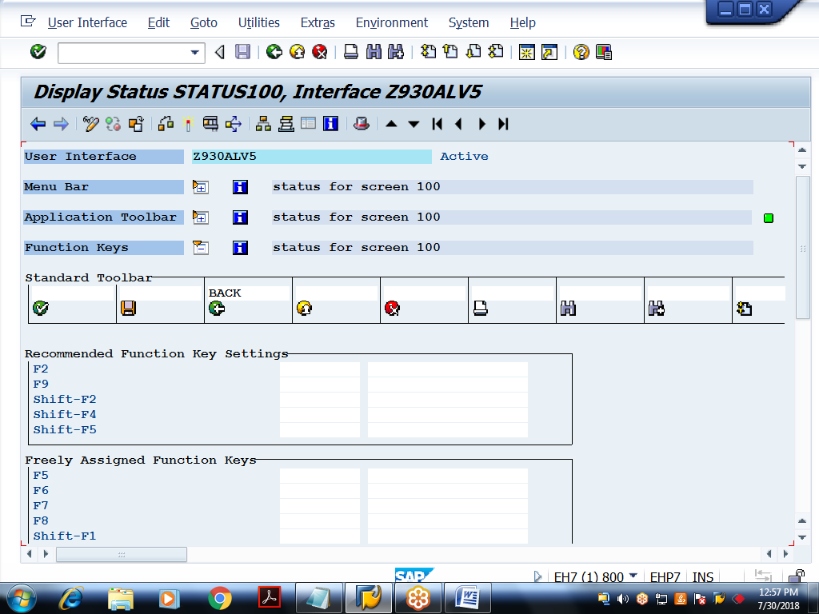
Layout of screen 100:
